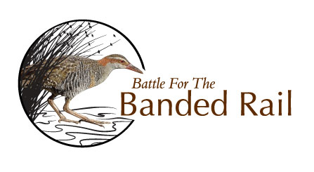

Come and join us at a Community Planting Day on the Waimea Inlet in 2021

Sunday 23rd May 9am – 1pm Bronte Peninsula on Stringer Embayment

Access from 62 Bronte Road East. Park on Bronte Rd

*Sat 29th/Sun 30th May 9am – 12pm* *Dominion Flats – Mapua & Districts Community Assn planting*

Sunday 13th June 9am – 1pm Manuka Island

Follow sign to Manuka Island from Redwood Road

Sunday 20th June 9am – 1pm Bronte Peninsula North

Park on Cardno Way (off Bronte Road East)

Sunday 27th June 9am – 1pm Stringer Creek

Westdale Road opposite The Playhouse Café

Sunday 4th July 9am – 1pm Hoddy Peninsula DOC Reserve Access from 57 Hoddy Road. Park on roadside edge Hoddy Road

Sunday 11th July 9am – 1pm Pukeko Lane Parking and access from Pukeko Lane

Sunday 18th July 9am – 1pm Research Orchard Road Reserve

Sunday 1st August 9am – 1pm Mapua Embayment/Seaton Valley Stream

Access and parking at 126 Aranui Road

Sunday 15th August 9am - 1pm Hunter Brown Reserve, Rough Island

Sunday 22nd August 9am - 1pm Reservoir Creek Embayment

Park at Aquatic Centre, walk through highway underpass to estuary

Sunday 29th August 9am - 1pm Hunter Brown Reserve, Rough Island

Sunday 5th September 9am - 1pm Greenslade Park, Rough Island

Sunday 12th September 9am - 1pm Hunter Brown Reserve, Rough Island

Please bring gloves, spade and drinking water. Wear solid footwear and clothes suitable for the weather conditions. Morning tea will be provided .

*Battle for the Banded Rail is a project working with local communities to increase the number of banded rail and other estuarine birds on the margins of the Waimea Inlet by restoring habitat and trapping predators.*

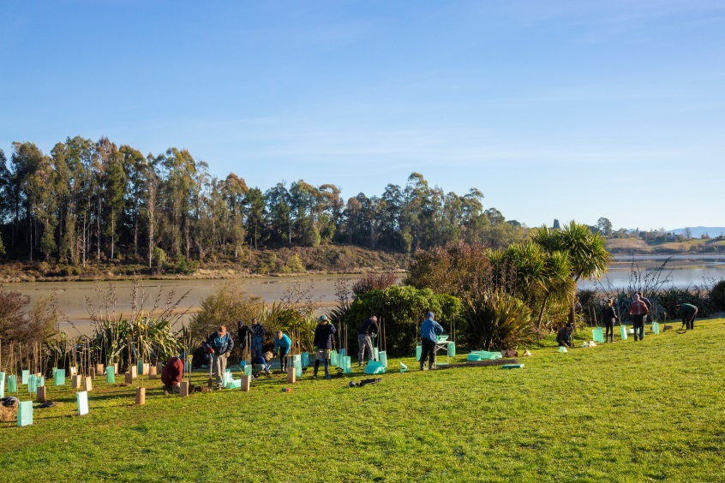[Logo](http://www.tasman.govt.nz/)For more information email us at [bandedrail@gmail.com](mailto:bandedrail@gmail.com) or phone Kathryn 544 4537